1. 
2. Other way to achieve thread safety is by using Atomic classes in java.
3. 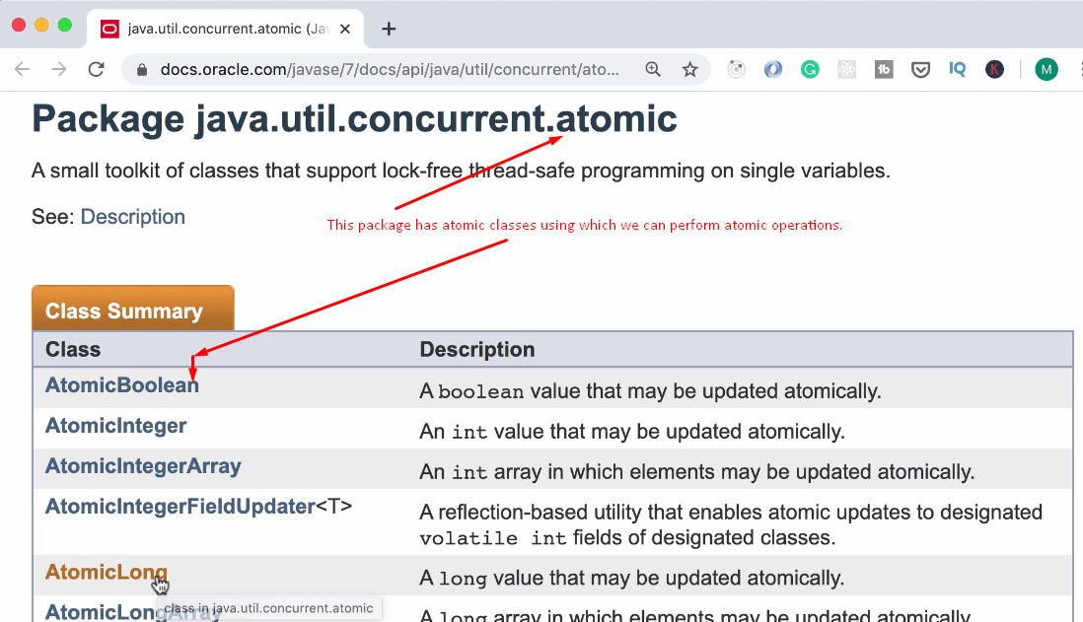
4. 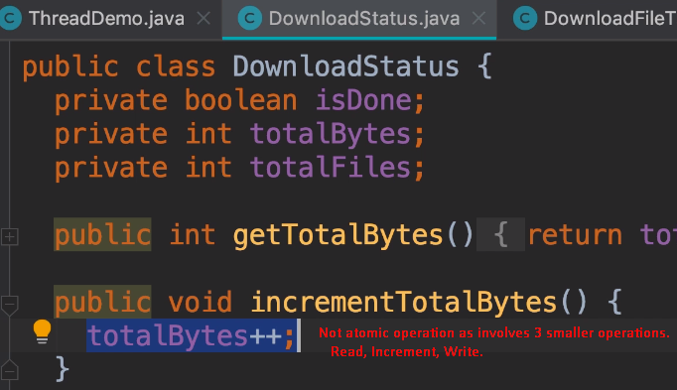
5. 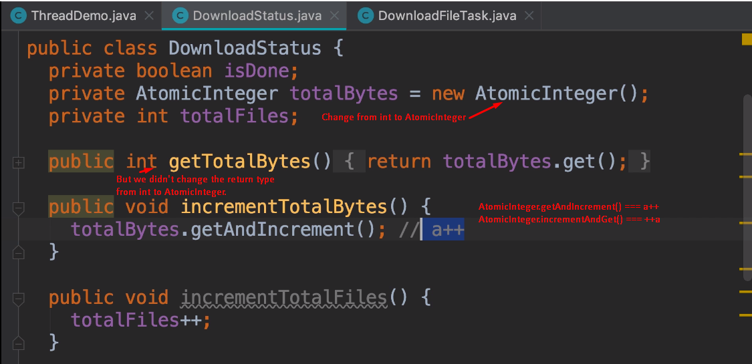
6. How Atomic classes work?
   1. There is a technique called **“Compare & Swap**” which is supported by most CPU. So most CPU can execute this operation as single and uninterrupted operation. 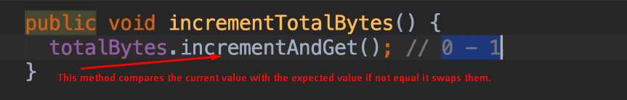 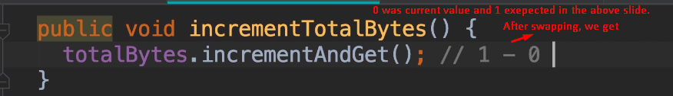
7. **NOTE**: Prefer Atomic Types to Synchronized keyword as they are faster.